Machine Description | A deliberately vulnerable lab machine for practicing web app exploits, privilege escalation, and post-exploitation to gain user and root access.
Target IP | 192.168.0.141
Vulnerability Name | - Weak WordPress Passwords  - WordPress User Enumeration  - Vulnerable Activity Monitor Script  - Weak System Password Found  - Sudo Misconfiguration  - Nmap NSE Execution as Root
Port / Service | TCP 80 / http
Severity | High 8.1
Attack Vetor | CVSS:3.0/AV:L/AC:H/PR:N/UI:N/S:C/C:H/I:H/A:H
Proof of Concept (PoC) | STEP 1 – Nmap to find the IP of the target machine.  STEP 2 – Nmap Scan to discover open ports and Services  # nmap –p- -sC –sV $ip –open  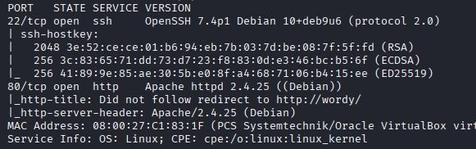  STEP 3 - Found a Wordpress login page    STEP 4 - Found 5 users using wpscan  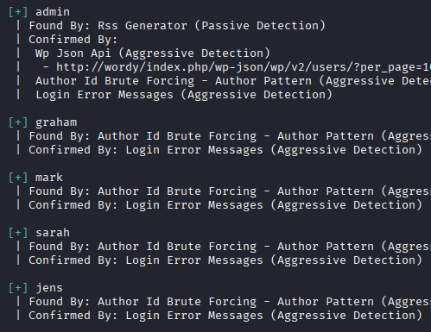  STEP 5 - There is a clue from the Author of the machine i.e.  Clue  OK, this isn't really a clue as such, but more of some "we don't want to spend five years waiting for a certain process to finish" kind of advice for those who just want to get on with the job.  cat /usr/share/wordlists/rockyou.txt | grep k01 > passwords.txt That should save you a few years. ;-)  STEP 6 - Found password for user mark  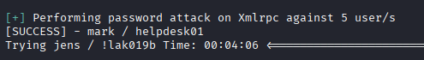  STEP 7 – We are logged in  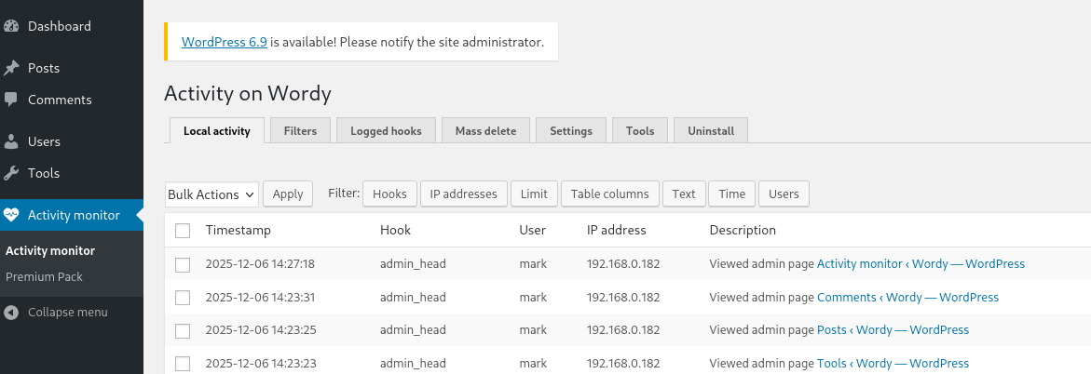  STEP 8 - There is an exploit for activity monitor (50110.py)  STEP 9 - Its requires valid user-password and IP, its not actual shell  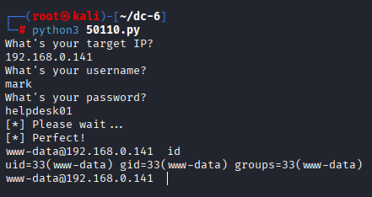  STEP 10 –  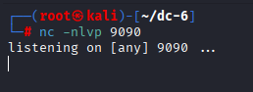  STEP 11 - use netcat for actual shell  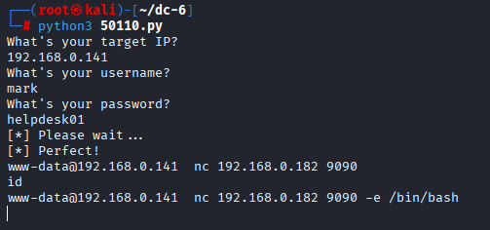  STEP 12 - Got Actual shell  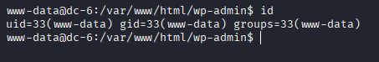  STEP 13 - Found a valid password  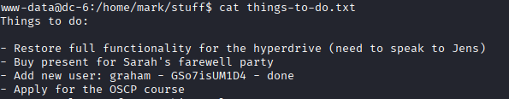  STEP 14 – We can run sudo on  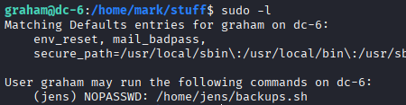  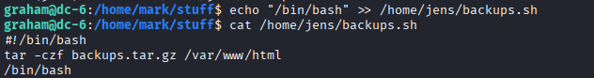  Step 15 – Added our code  Step 16 – We executed the script as user jens  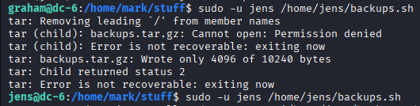  Step 17 – We can execute nmap as root without password  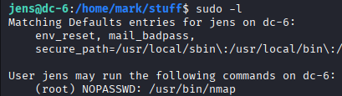  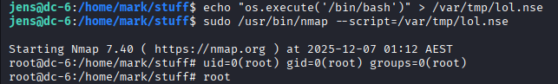  Step 18 – Created a .nse script and executed it  PROOF:  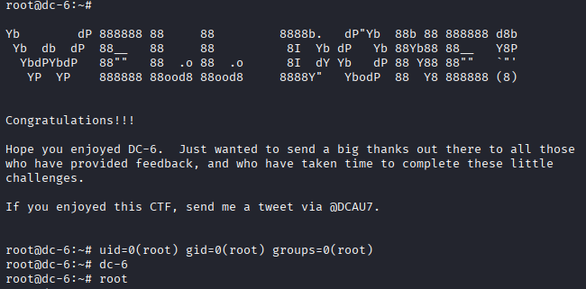
Remediation | - Use strong passwords, update WordPress  - Disable author listing / REST API  - Allows command execution / privilege escalation  - Lets attacker move to other accounts  - Fix sudoers file, remove unnecessary privileges  - Remove NOPASSWD for nmap, restrict NSE
Impact | - Attackers can log in and take over the site.  - Makes password attacks easier.  - Allows command execution / privilege escalation  - Lets attacker move to other accounts  - User can run commands as root → full system compromise  - Root access through Nmap scripts
References | https://wordpress.com/support/passwords/  https://wordpress.com/support/security/  https://www.kaspersky.com/resource-center/definitions/code-injection  https://www.ncsc.gov.uk/collection/top-tips-for-staying-secure-online/passwords  https://www.techtarget.com/searchsecurity/definition/privilege-escalation  https://www.avast.com/c-privilege-escalation

